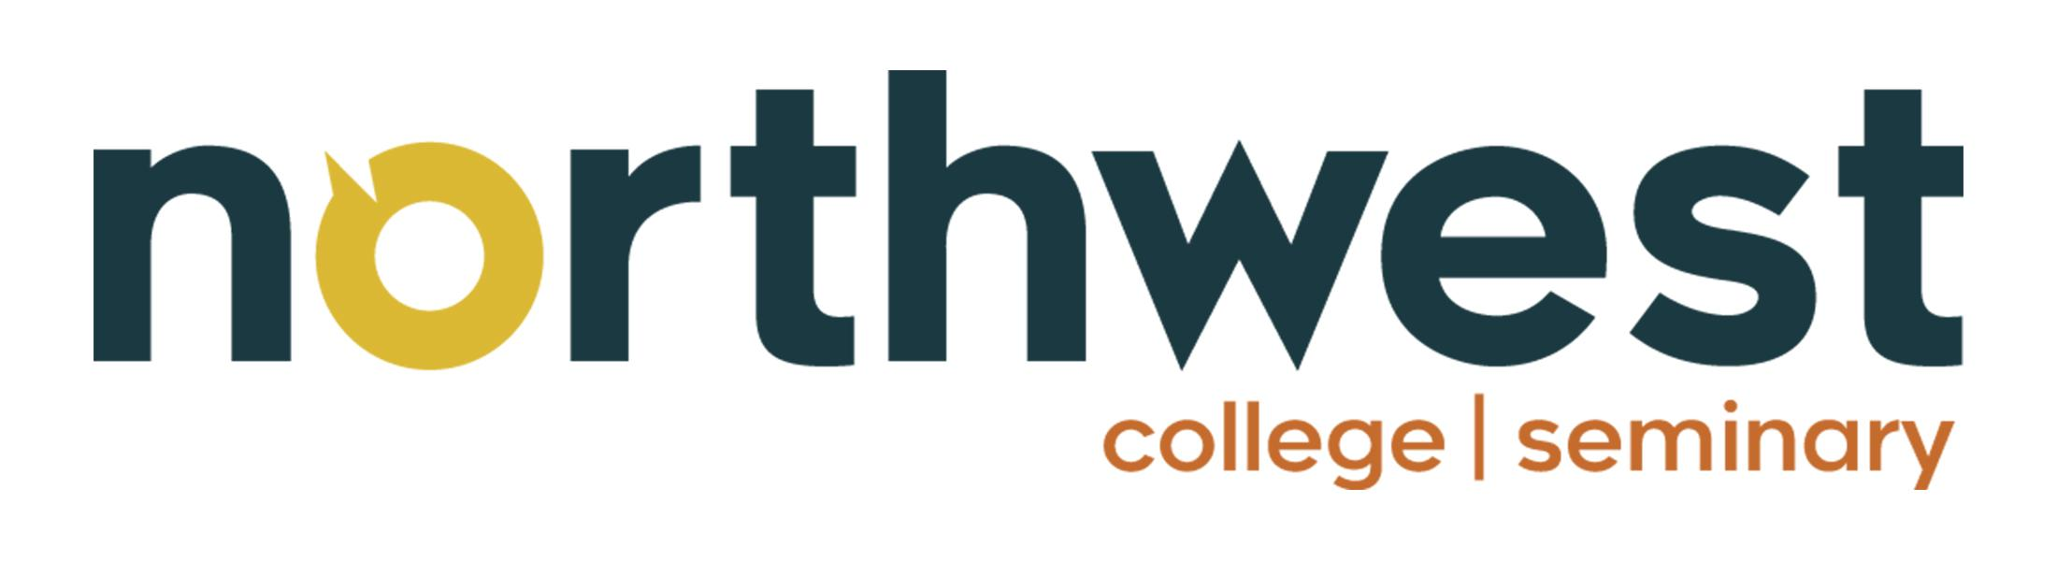
Network Quality Indicators
Competency-Based Theological Education
Network Evaluation & Accountability Template

Network Name: |  | Review Period:
Network Coordinator: |  | Date Completed:

Purpose: This evaluation template is designed to help networks assess the health and effectiveness of their partnership with Northwest College and Seminary in training church leaders and pastors through Competency-Based Theological Education (CBTE). Use this tool annually or semi-annually to track progress, identify gaps, and celebrate growth.

1. Enrollment

1.1 Enrollment Assessment Strategy
Describe the process used to identify, recruit, and assess potential students within the network:

Quality Indicator | Notes / Evidence
A documented enrollment process is in place
A point person or enrollment coordinator is identified
Candidates are assessed for calling, character, and capacity prior to enrollment
Application or intake interview process is used
Orientation is provided to new students
Prospective students are connected to a mentor prior to starting

1.2 Enrollment Goals
Metric | Goal (Annual) | Actual | Notes
New students enrolled
Students re-enrolled after pause
Students from new churches in network
Target number of active students
Retention rate (year over year)

1.3 Student Diversity and Reach
Metric | Goal (Annual) | Actual | Notes
Number of churches represented
Number of communities/regions represented
Students from underrepresented communities
Indigenous or cross-cultural ministry students

2. Mentor Engagement

2.1 Mentor Engagement Indicators
Indicator | Frequency / Target | Actual | Notes
Mentor-student meetings per term | Minimum 1/month
Mentors trained or oriented by NWC&S | Annually
Mentor participation in cohort gatherings
Mentor feedback submitted on student progress | Per competency
Mentors who report feeling equipped and supported
New mentors recruited this period

2.2 Mentor Development
Describe any training, resources, or support provided to mentors this period:

Development Area | Notes
Mentor orientation completed
CBTE philosophy and methodology training
Feedback and assessment skills training
Spiritual formation coaching resources provided

3. Student Academic Progress

3.1 Pace of Student Work
Metric | Target | Actual | Notes
Average competencies completed per student/term
Students on track with their learning plan
Students behind pace (flagged for support)
Students who paused or withdrew this period
Average time to complete a credential/degree

3.2 Competency & Credential Completion
Metric | Target | Actual | Notes
Competencies approved this period (total)
Students who completed a credential
Students who graduated this period
Credentials or degrees most commonly pursued

3.3 Spiritual Formation Engagement
Indicator | Target | Actual | Notes
Students engaged in active spiritual direction
Students participating in a learning community/cohort
Evidence of formation reflected in mentor assessments

4. Seminar Engagement

4.1 Seminar Attendance Report
Seminar Title / Date | # Invited | # Attended | Notes

4.2 Seminar Engagement Quality
Indicator | Target | Actual | Notes
Average attendance rate across all seminars | 80%+
Student satisfaction / feedback scores | Positive
Seminars attended by mentors
Seminars facilitated locally by the network
Seminars connected to active competencies

5. Ministry Placement & Impact

5.1 Placement in Ministry
Metric | Goal | Actual | Notes
Students currently serving in a ministry role
Students placed in new ministry roles this period
Students serving as lead/senior pastors
Students in church planting roles
Students in cross-cultural or missions roles
Students serving in parachurch or non-profit ministry
Students who moved into ministry due to their CBTE program

5.2 Church and Network Impact
Indicator | Goal | Actual | Notes
Churches in the network with active CBTE students
New churches engaged in the CBTE program
Network leaders who are alumni of the program
Churches strengthened by student ministry contribution

6. Recognition of Prior Learning & RRA

6.1 RRA (Recognition of Related Achievement) Report
Complete one row per student with an active RRA submission this period:

Student Name | Competency/Area | RRA Submitted | Status | Notes

6.2 RRA Summary Metrics
Metric | Target | Actual | Notes
Total RRA submissions this period
RRA submissions approved
RRA submissions pending
RRA submissions returned for revision
Competencies granted through RRA

7. Network Health & Coordination

7.1 Leadership and Communication
Indicator | Target | Actual | Notes
Network coordinator meetings with NWC&S | Quarterly
Network coordinator satisfaction with support | High
Communication touchpoints with students | Monthly
Concerns or issues escalated and resolved
Network strategic plan reviewed or updated | Annually

7.2 Financial Sustainability
Indicator | Target | Actual | Notes
Students with active financial support/sponsorship
Students experiencing financial barriers to progress
Scholarships or bursaries applied for
Network funding committed to CBTE program

7.3 Partnership with Northwest College and Seminary
Indicator | Target | Actual | Notes
Network satisfaction with NWC&S support services
Issues or feedback communicated to NWC&S
Joint initiatives planned or completed
NWC&S staff visit(s) to the network this period

8. Summary and Action Plan

8.1 Overall Network Health Rating

Area | Rating (1-5) | Comments
Enrollment | / 5
Mentor Engagement | / 5
Student Progress & Pace | / 5
Seminar Engagement | / 5
Ministry Placement | / 5
RRA Process | / 5
Network Health & Coordination | / 5

8.2 Key Wins This Period

8.3 Key Challenges This Period

8.4 Action Items for Next Review Period
Action Item | Responsible Person | Target Date

8.5 Signatures

Network Coordinator Signature | NWC&S Representative Signature
Date: | Date:

Northwest College and Seminary | Competency-Based Theological Education
This document is a confidential network evaluation tool. Please retain for your records.

